**SCREENSHOT OF SIGN- UP PAGE:**

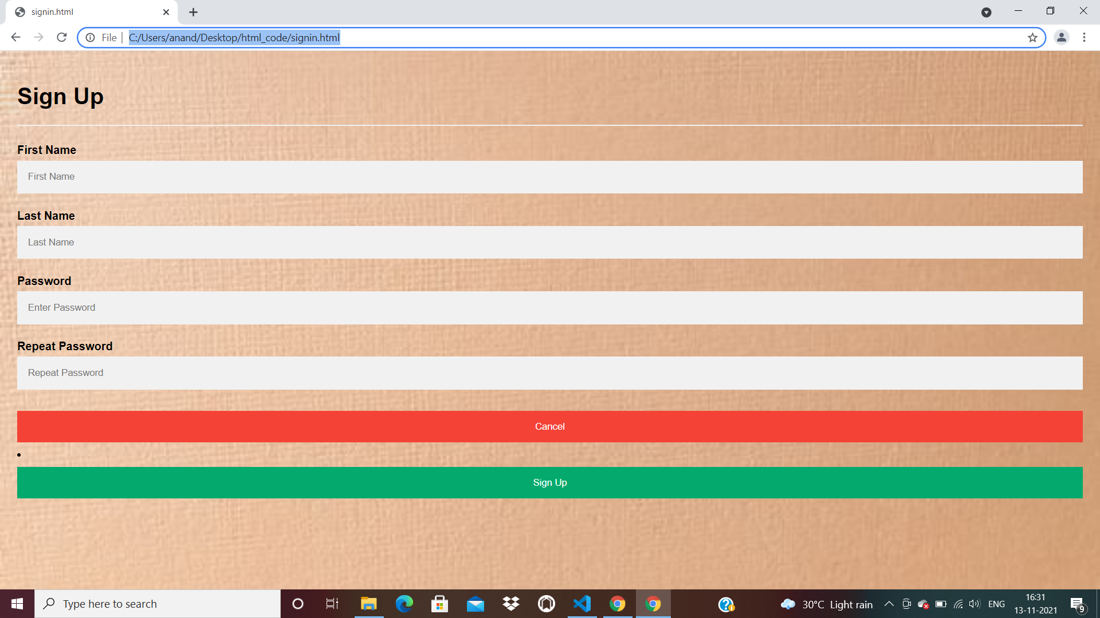

**SCREENSHOT OF LOG-IN PAGE:**

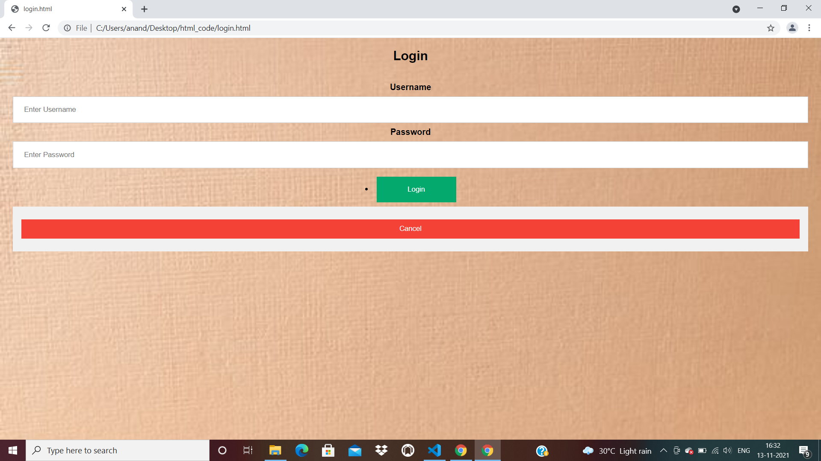

**SCREENSHOT OF HOME PAGE:**

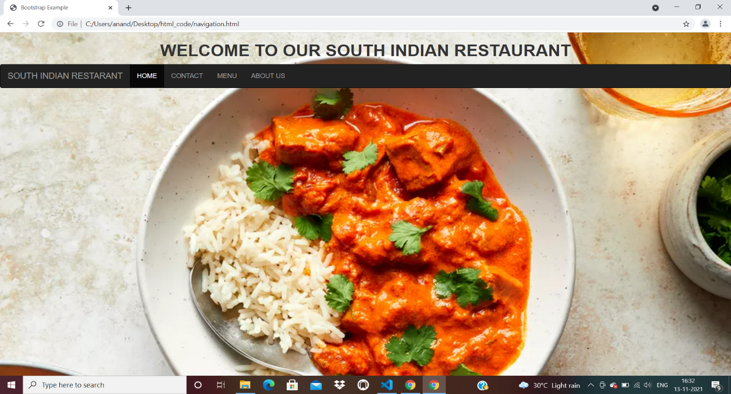

**SCREENSHOT OF CONTACT PAGE:**

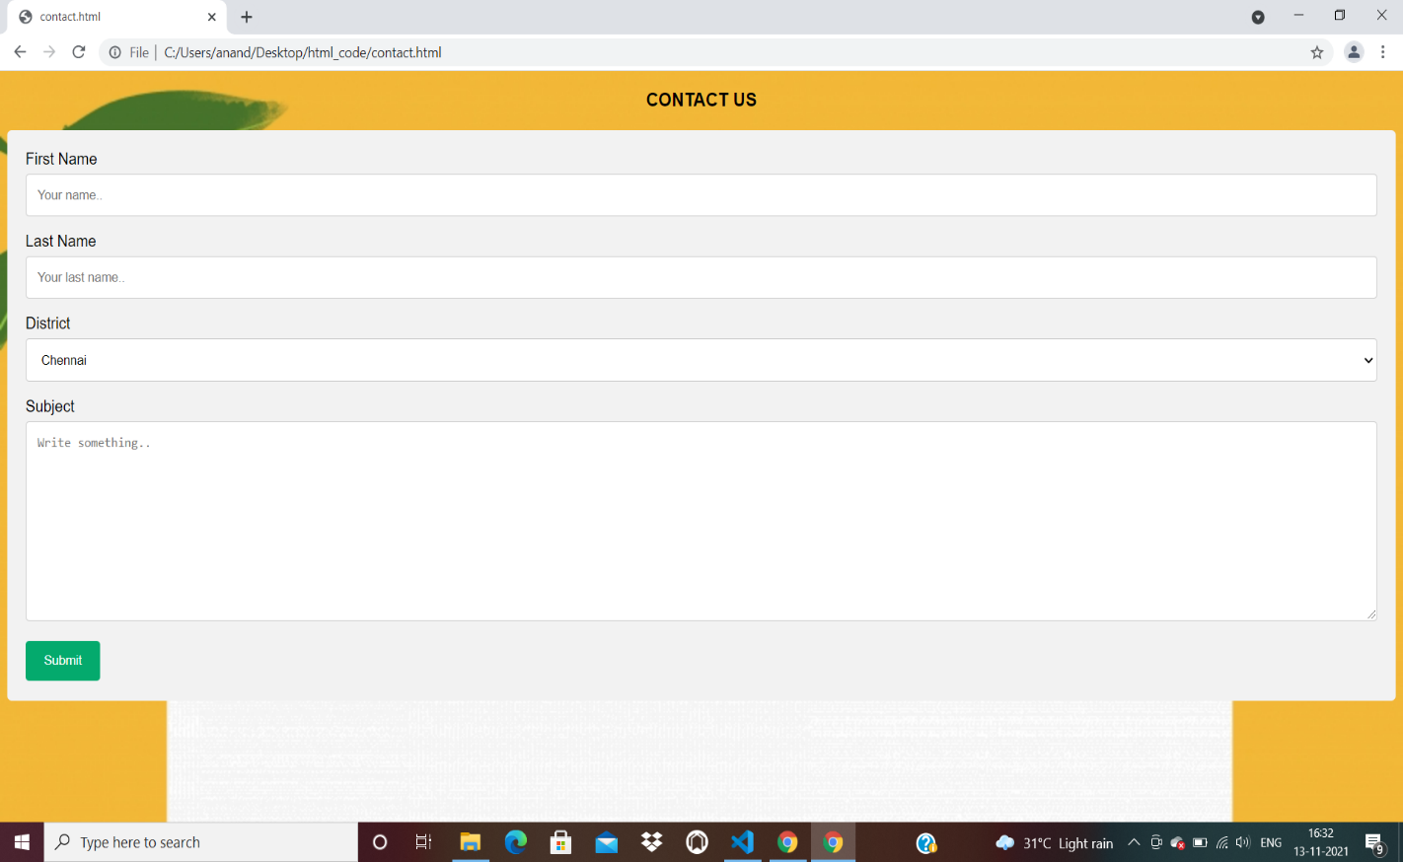

**SCREENSHOT OF MENU PAGE:**

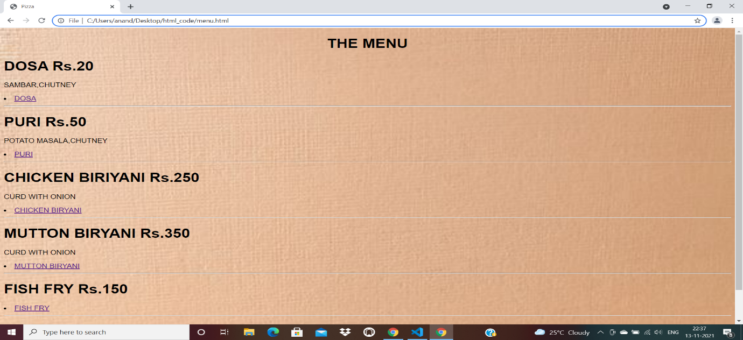

**SCREENSHOT OF BILL AND PAYMENT:**

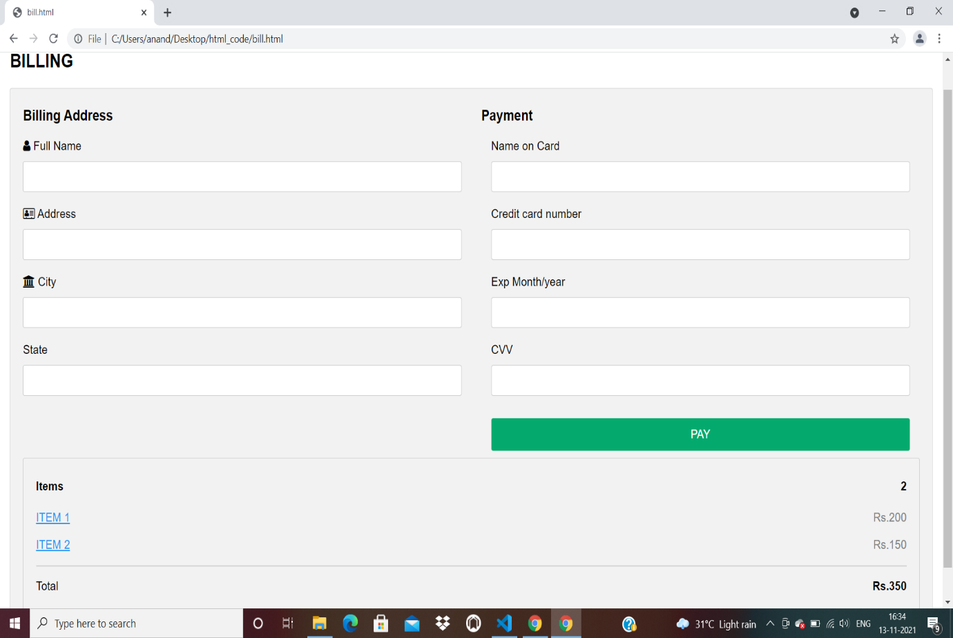

**SCREENSHOT OF ABOUT US:**

